Normal Distribution

- Introduction
- Importance
- Characteristics
- Limiting cases
- Area under the normal curve

Normal Distribution.

The normal distribution was first discovered in 1733 by English mathematician De-Moivre. Who obtained this continuous distribution as a limiting case of the binomial distribution and applied it to problems arising in the game of chance. It was also known to Laplace, no later than 1774 but through a historical error it was credited to Gauss. Who first made reference to it in the beginning of 19th century (1809), as the distribution of errors in Astronomy.

Gauss used the normal curve to describe the theory of accidental errors of measurements involved in the calculation of orbits of heavenly bodies. Throughout the eighteenth and nineteenth centuries, various efforts were made to establish the normal model as the underlying law ruling all continuous random variables. Thus the name "normal”. These efforts, however, failed because of false premises. The normal model has, nevertheless, become the most important probability model in statistical analysis.

The most important continuous probability distribution in the entire field of statistics is the normal distribution. Its graph, called the normal curve, is the bell-shaped curve. For example, physical measurements in areas such as meteorological experiments, rainfall studies, and measurements of manufactured parts are often more than adequately explained with a normal distribution. The normal distribution is often referred to as the Gaussian distribution, in honor of Karl Friedrich Gauss (1777–1855), who also derived its equation from a study of errors in repeated measurements of the same quantity. A continuous random variable X having the bell-shaped distribution of Figure 6.2 is called a normal random variable.

The mathematical equation for the probability distribution of the normal variable depends on the two parameters μ and σ, its mean and standard deviation, respectively. Hence, we denote the values of the density of X by n(x; μ, σ).

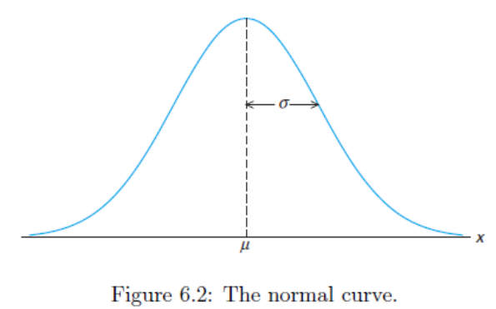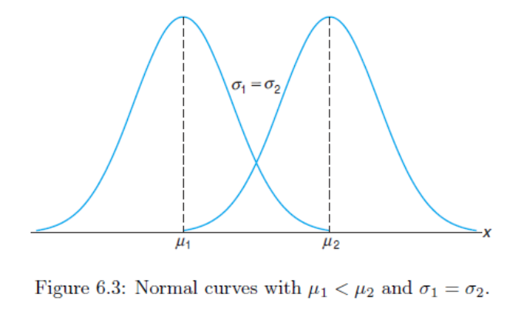

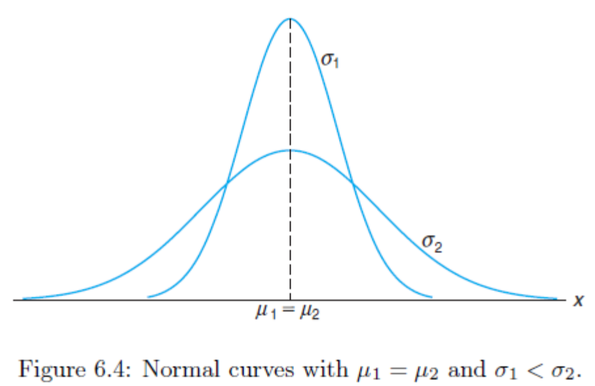
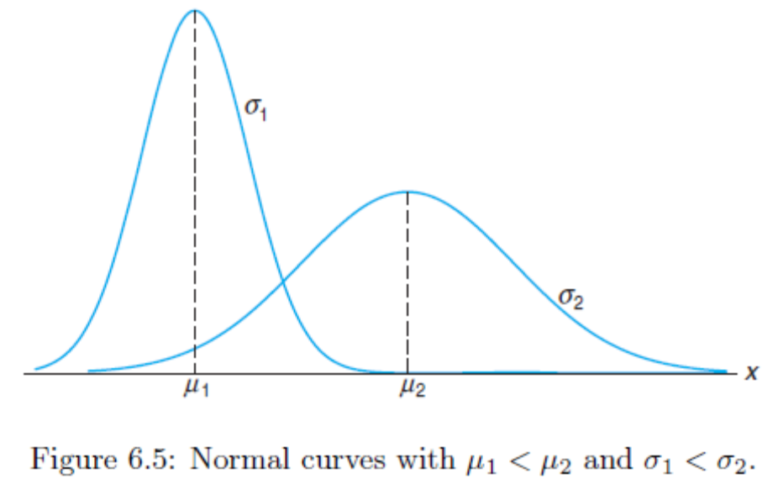

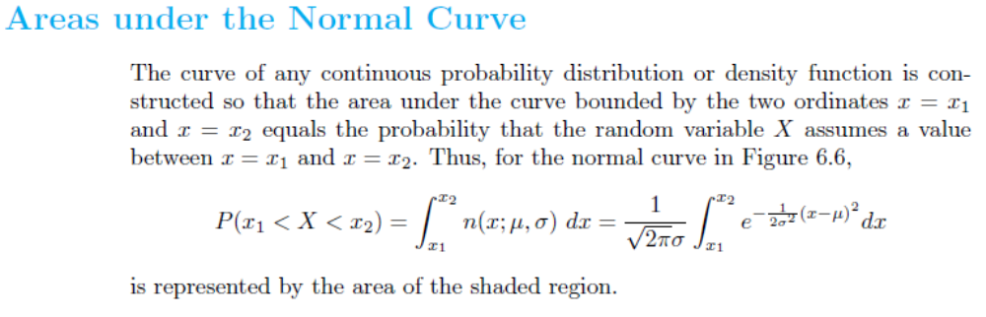
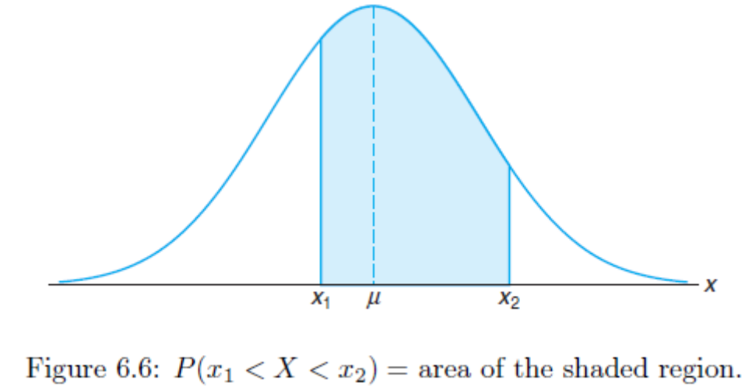
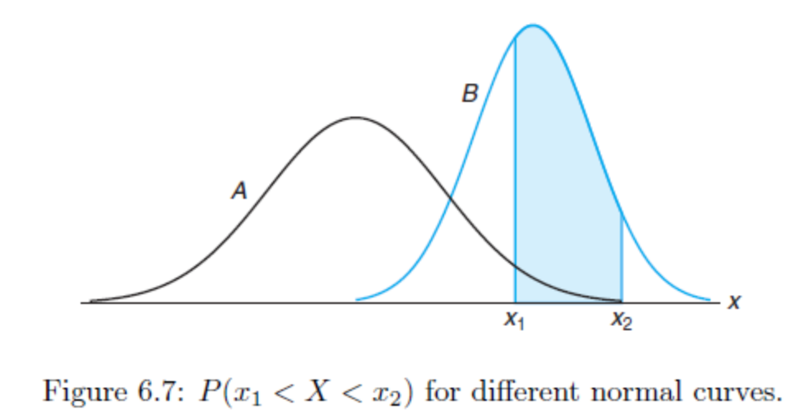
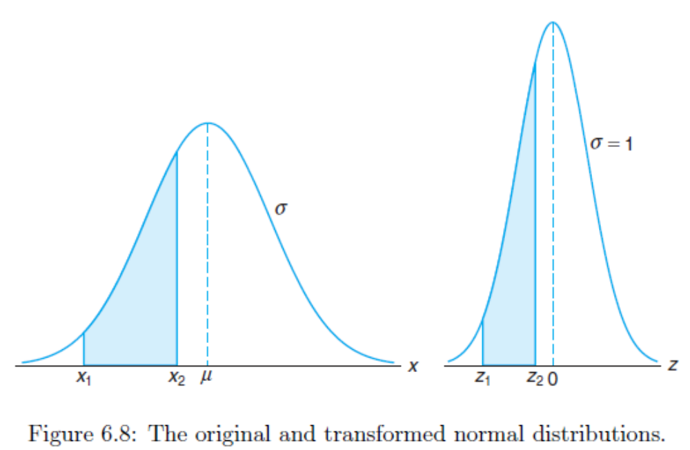

Definition:

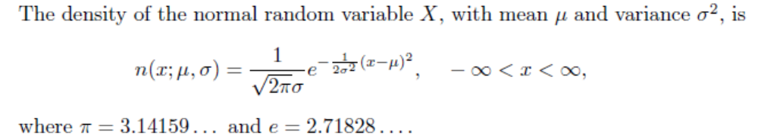

Once μ and σ are specified, the normal curve is completely determined. For example, if μ = 50 and σ = 5, then the ordinates n(x; 50, 5) can be computed for various values of x and the curve drawn.

The following properties of the normal curve:

1. The mode, which is the point on the horizontal axis where the curve is a maximum, occurs at x = μ.

2. The curve is symmetric about a vertical axis through the mean μ.

3. The curve has its points of inflection at x = μ ± σ; it is concave downward if μ −σ <X < μ+ σ and is concave upward otherwise.

4. The normal curve approaches the horizontal axis asymptotically as we proceed
in either direction away from the mean.

Note: The total area under the curve and above the horizontal axis is equal to 1.

Note: The mean and variance of n(x; μ, σ) are μ and σ2, respectively. Hence, the standard deviation is σ.

Definition: The distribution of a normal random variable with mean 0 and variance 1 is called a standard normal distribution.

Example:
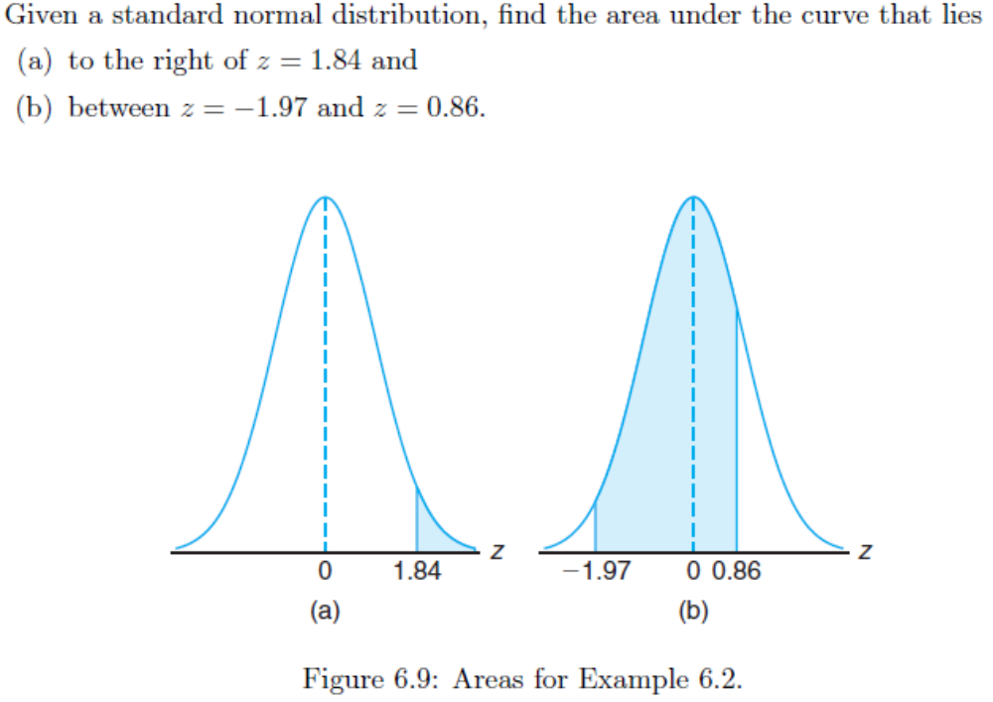
Solution:

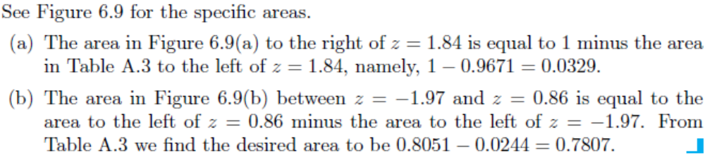

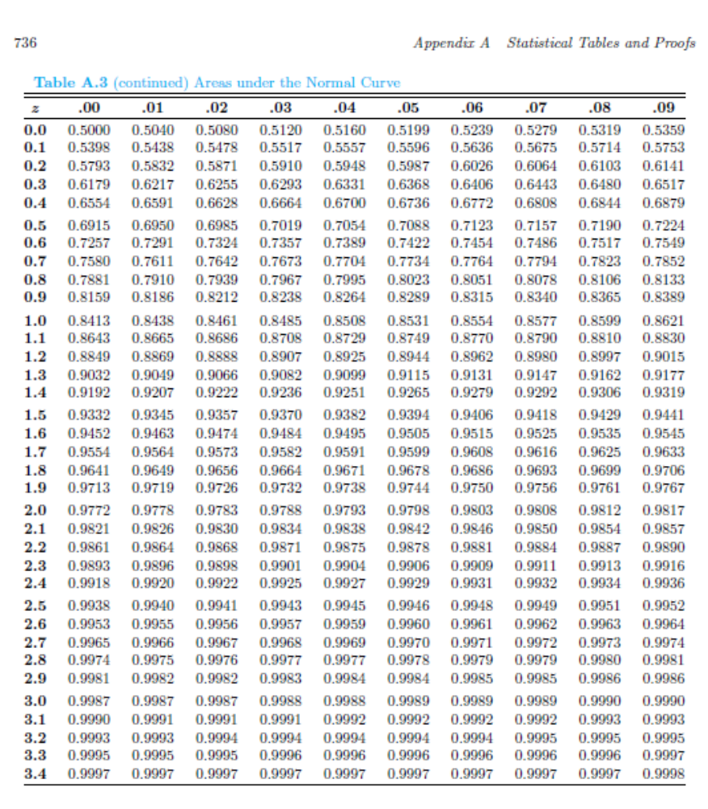

Example:
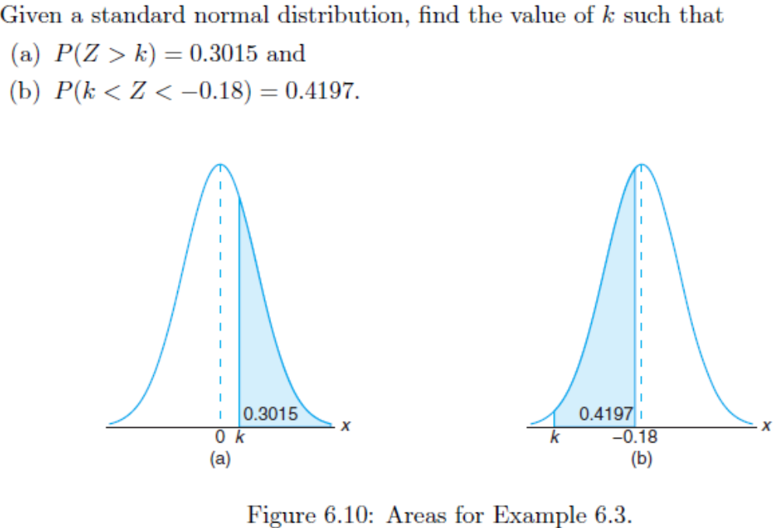
Solution:
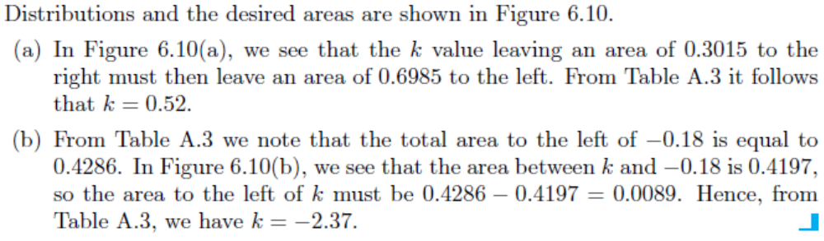
Example:
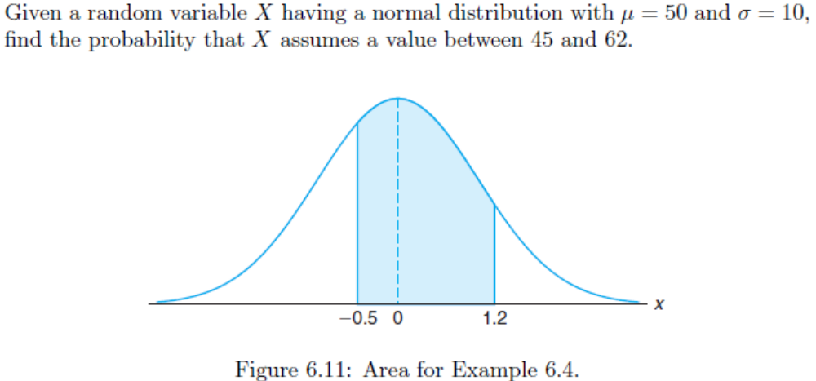

Solution:
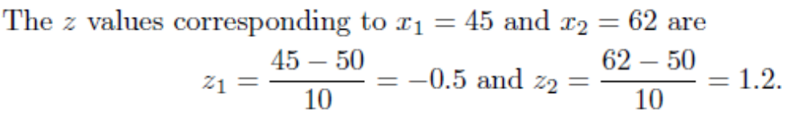
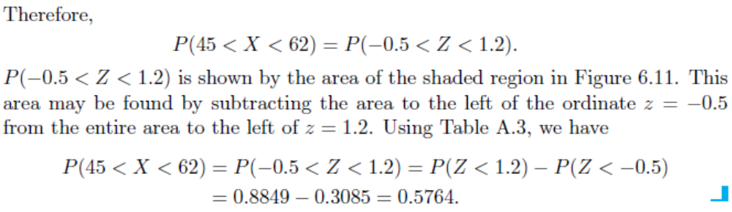
Example:
Solution:
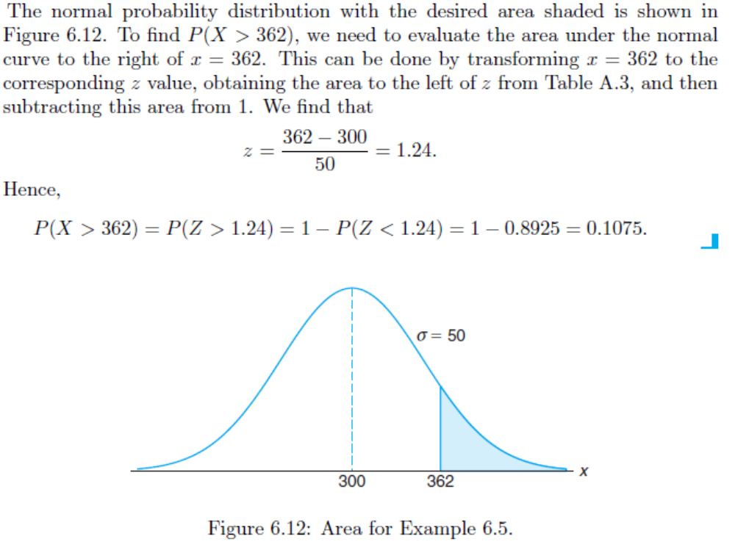

Example:
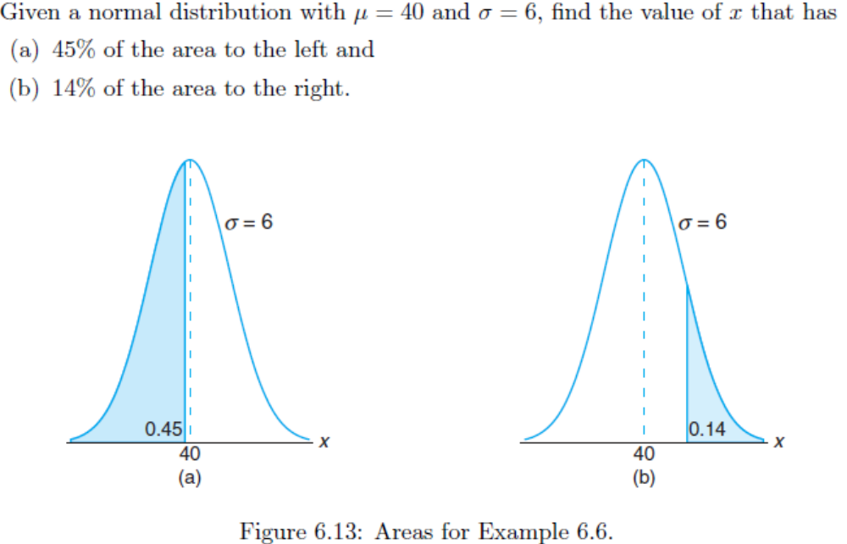
Solution:
